Start Window

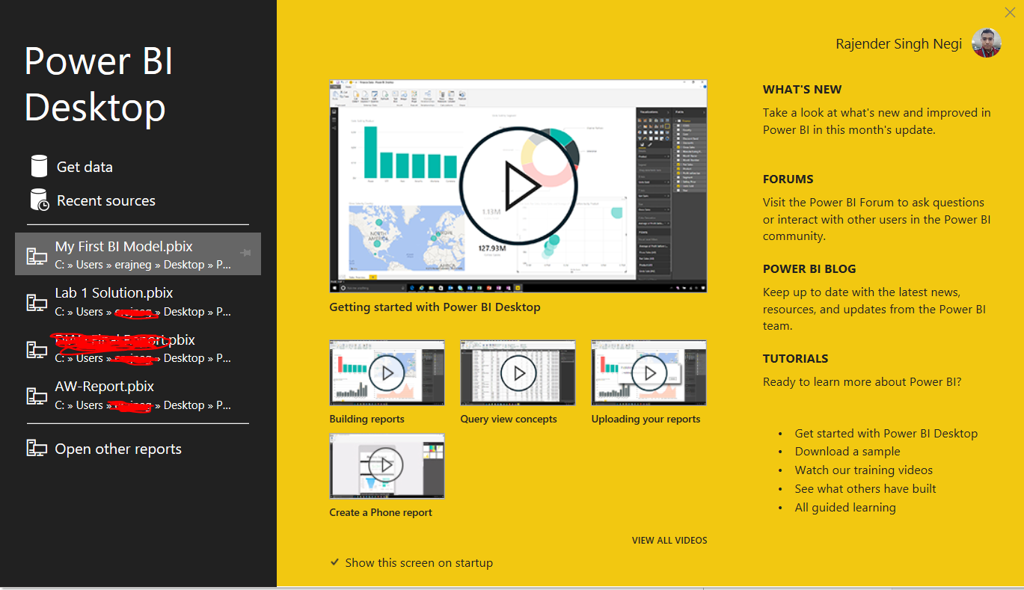

Report View

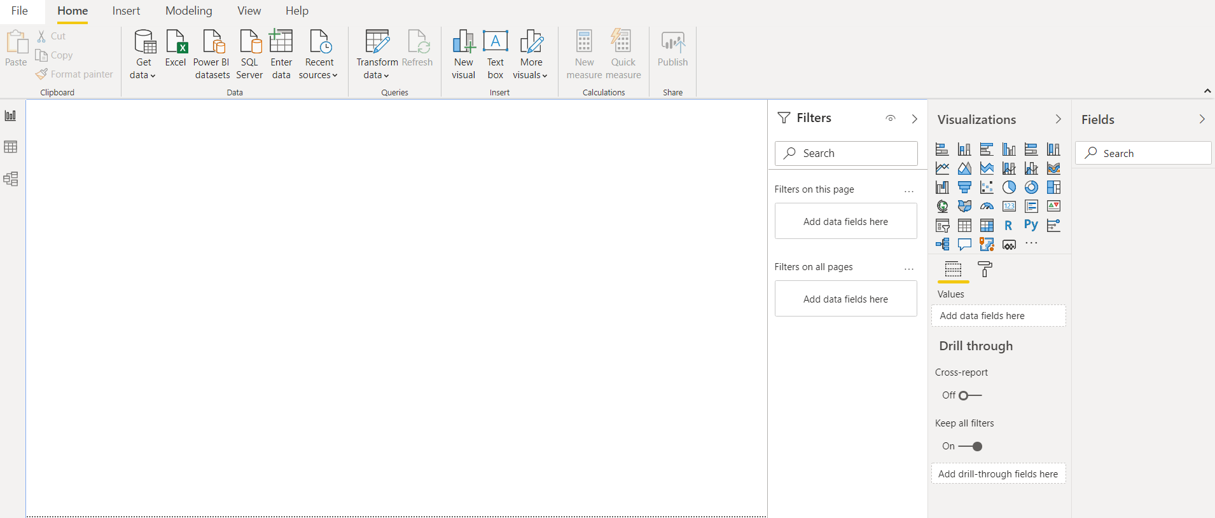

Data View

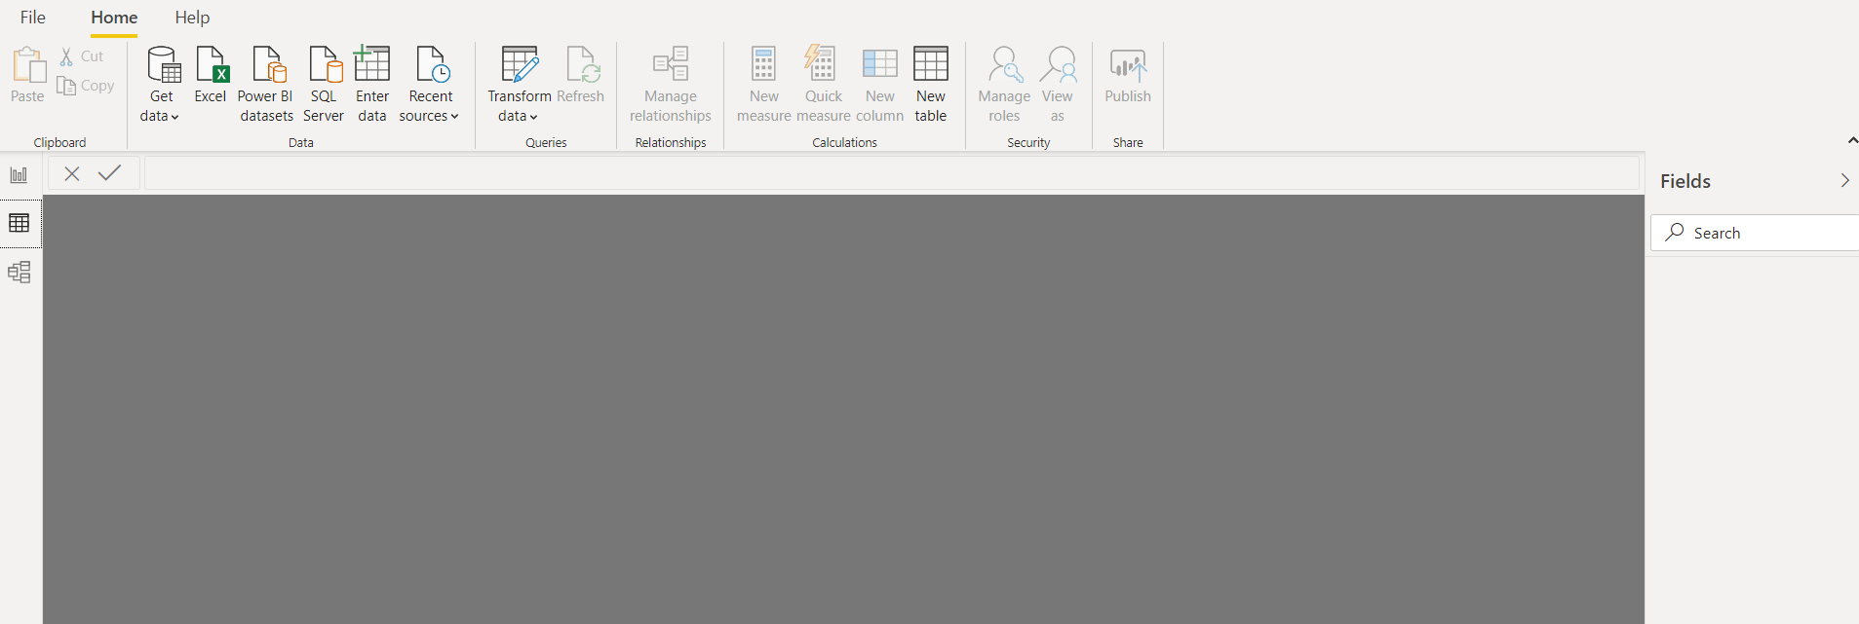

Power Query Window

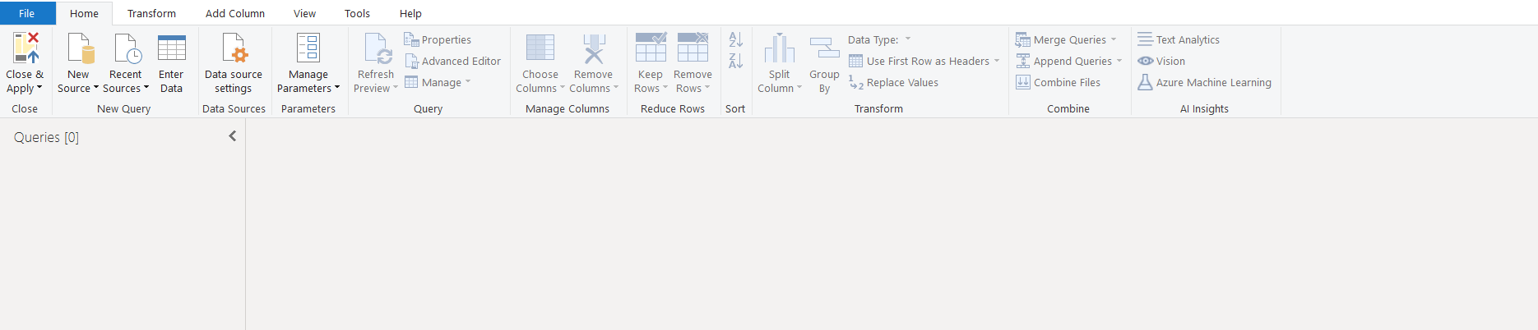

Advance Editor

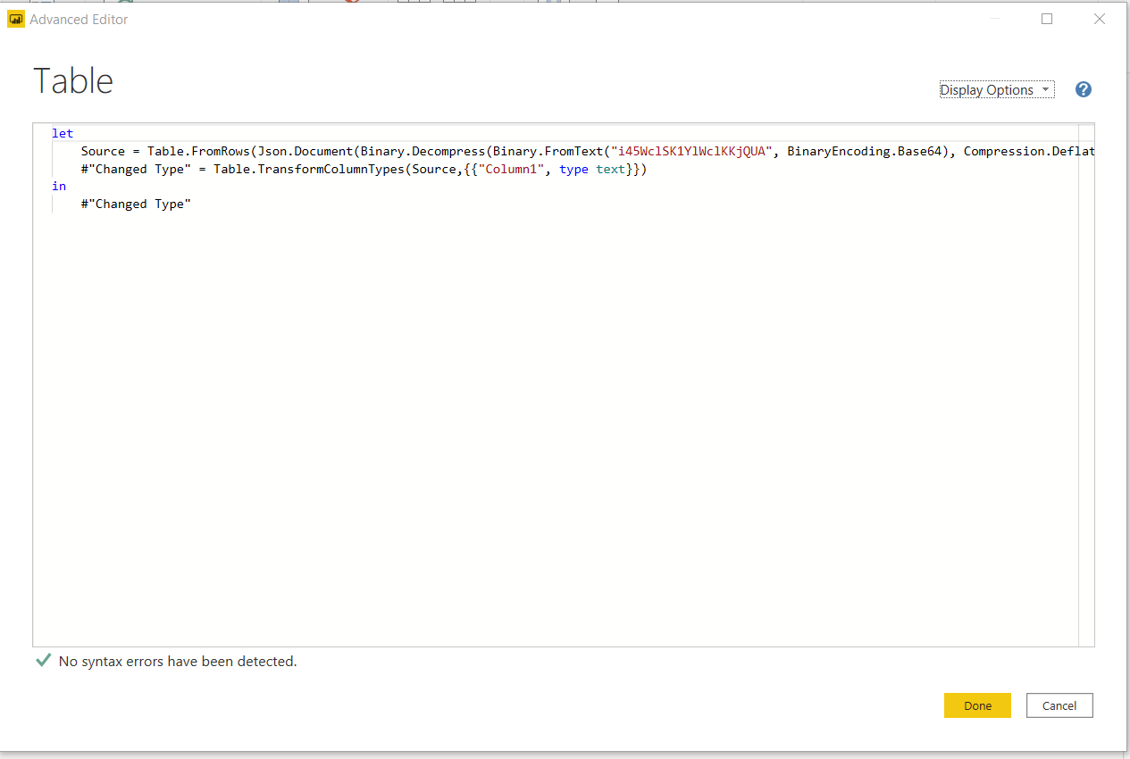

**Power BI Charges**

|  |  |  |
| --- | --- | --- |
| Power BI Desktop | Free |  |
| Power BI Pro | $9,99 | monthly/user |
| Power BI Premium | $4,995 | Monthly price per dedicated cloud compute and storage resource with annual subscription |